|  |  |
| --- | --- |
|  | **CS 415: Software Engineering**  **Lab Exercise 4 (Friday 12th July 2024)** |

**Instructions**

You are expected to work individually on this lab exercise.

DO NOT USE ANY AI AGENT in this lab exercise! **[30 POINTS]**

**Submission**: Complete this document with your answers and submit individually on CANVAS. **Deadline is Monday 15th July 2024 at 11:55pm.**

**SOFTWARE ARCHITECTURE [30 Points]**

Refer to a Figure 1 below with the business model for UBER:

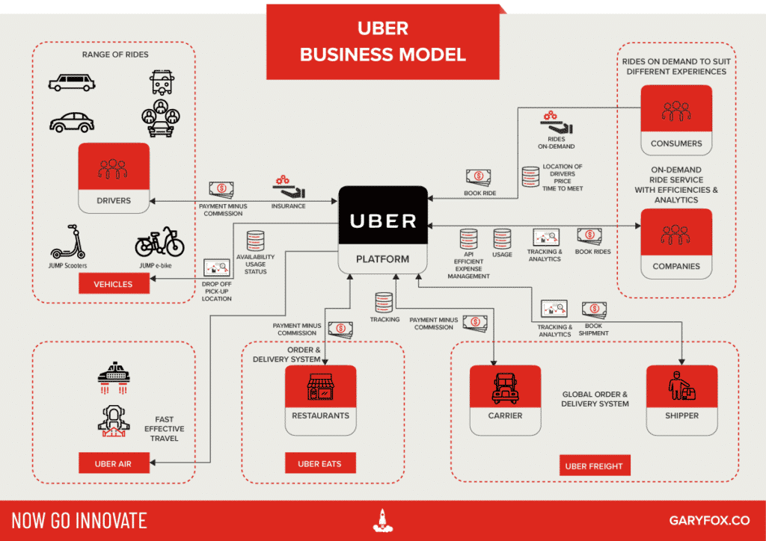

Figure 1: Business Model for UBER

**Questions**

1. [**5 points**] List at least five (5) *modern software architecture* below.
2. [**35 points**] In your expert assessment, *justify* which dominant modern software architecture will be most appropriate to represent the UBER software system [10 points]. Provide a *software architecture artefact/diagram* with explanations focusing on your justified modern software architecture above [25 points].